Credit Models


Homework 3:
Stock Market Risk Analysis

Professor:
Rodolfo Slay Ramos

Presented by:
David Campos Ambriz – 744435

Stock Market Risk Analysis Report
Risk assessment in companies requires robust tools and methods that go beyond a superficial observation of a company's price history. To determine a company's true financial health, methods such as the Altman Z-score and Melton score exist. These methods, through quantitative models and a company's historical accounting data, help us understand a company's true solvency and probability of bankruptcy over a given period.
That said, the main objective of this report is to apply both complementary methodologies to assess the credit risk of some companies listed on the US stock exchange. To this end, a Python model was developed that extracts the financial data of a company of interest directly from Yahoo! Finance and uses it to calculate each company's risk indicators. Finally, using these same results as an assessment, a recommendation is issued as to whether the company in question is suitable for receiving credit.

Modelo Altman Z-score
This model was developed by Edward Altman as a multiple discriminant analysis model that uses certain financial data from a company to attempt to predict the likelihood of bankruptcy in the short and medium term. The "original" version of this model was initially published in 1968 and has subsequently been updated over time, receiving improvements and changes that have helped it adapt to companies in different sectors or be applied in different economic contexts.
In this work, two variants of this same model were implemented in an attempt to obtain a more tailored analysis for the specific sector of the company.

Original 1968 Model (Manufacturing Companies)
This model evaluated a company based on five financial points::
$$Z=1.2X_{1}+1.4X_{2}+3.3X_{3}+0.6X_{4}+1.0X_{5}$$
Where:
$X_{1}$- Is the Liquidity : Working Capital / Total Assets. It measures net liquid assets in relation to total capitalization.
$X_{2}$- It is the Accumulated Profitability: Retained Earnings / Total Assets. It reflects the age and historical purchasing power of the company.
$X_{3}$- Represents Operating Efficiency: EBIT / Total Assets. It measures the true productivity of assets, isolated from tax and leverage factors.
$X_{4}$- Is Market Leverage: Market Cap / Total Liabilities. It indicates how much the value of assets can fall before debt exceeds equity.
$X_{5}$- Indicates Asset Turnover: Sales / Total Assets. It measures management's ability to generate revenue from assets.

For the results of this model, certain ranges have been established to provide an idea of ​​the classification of a company's financial status when assessing its suitability for receiving credit.
- Safe Zone, indicating financial strength and viability for credit approval:
$$Z>2.99$$
Grey Zone, indicating uncertainty. That is, the company may have vulnerabilities:
$$1.81≤Z≤2.99$$
Distress Zone, indicating a potential insolvency warning and therefore grounds for denying credit:
$$Z<1.81$$

Altman Z Model (Emerging and Non-Manufacturing Markets)
While the previous model is functional and has a certain degree of accuracy, it tends to fail when applied to diverse types of industries than those for which it was originally designed. This is due to $X_{5}$ which varied constantly depending on the type of industry. Therefore, this new model proposes eliminating this variable as a way to mitigate sectoral bias and instead uses the book value of capital in $X_{4}$:
$$Z''=6.56X_{1}+3.26X_{2}+6.72X_{3}+1.05X_{4}$$
The ranges for this model are::
- Safe Zone
$$Z''>2.6$$
- Grey Zone
$$1.1≤Z''≤2.6$$
- Distress Zone
$$Z<1.1$$

Modelo de Merton
The defining characteristic of the Merton model is that, unlike the Altman model which relies on accounting ratios, this model considers the randomness of the problem and utilizes Black-Scholes option pricing as well as market dynamics. In principle, this model assumes that a company's equity ($E$) can function as a call option on the total value of its assets ($V$) indicating that the strike price is equivalent to the total value of its debt ($D$). Therefore, if at the maturity of the debt at time $T$, the value of the assets $V$ is less than $D$ (debt), the shareholders do not exercise the option, and consequently, the company defaults.
Perhaps the only drawback of this model is that it operates under the assumption that we know and have all the data readily available, which is not the case. Given that the market value of the assets and their volatility are not directly observable values, it may be necessary to numerically solve for the values ​​of these variables using observable data such as market capitalization, equity volatility, and the total value of debt.
Once all the necessary values ​​are obtained, the model begins by calculating the distance to default, or "DD," which measures how many standard deviations the expected value of the assets is from the critical bankruptcy point or the debt value:
$$DD=\frac{\ln\left(\frac{V}{D}\right)+\left(r-0.5σ_{V}^{2}\right)ΔT}{σ_{V}\sqrt{ΔT}}$$
Where $r$ is the risk-free rate and $T$ represents the time period.
Next, it calculates the probability of default, or "PD," which is obtained by applying the cumulative normal distribution function $N$ to $DD$ or “distance to default.”
$$PD=1-N(DD)$$
Once this value is obtained, the probability must be evaluated using predefined decision parameters to determine the company's risk level:
- Safe Zone, which in this case indicates a significant distance from default and therefore demonstrates solid solvency.
$$PD<2.0\%$$
- Grey Zone, which indicates uncertainty or moderate risk..
$$2.0\%≤PD≤5.0\%$$
- Distress Zone, which would indicate a high probability of defaulting on its obligations, thus disqualifying the company from receiving credit.
$$PD>5.0\%$$

Implementation
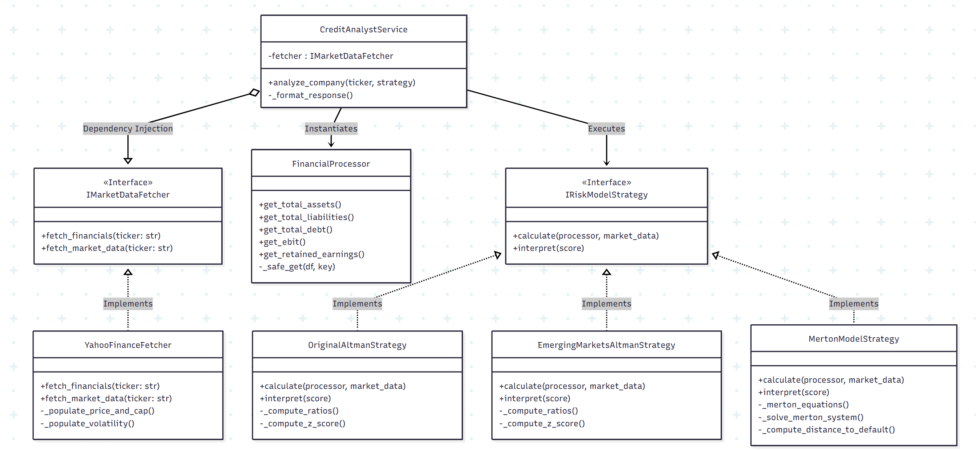
To expedite the code development process, it was built using object-oriented programming, as shown in the diagram above, following this procedure:
- First, data is extracted from Yahoo! Finance, filtering for the accounting metrics necessary for this exercise.
- Next, the three models (OriginalAltmanStrategy, EmergingMarketsAltmanStrategy, and MertonModelStrategy) are processed separately. These models use the obtained data to calculate the valuation and determine its position within each range.
- Finally, the results are sent to the dashboard, where the final results and the final recommendation are displayed. This recommendation is contingent upon at least one of the Altman models and the Merton model assigning the company a "safe zone" rating.

Results
When evaluating the different selected companies::
- AAPL: Apple Inc. Technology company
- FCX: Freeport-McMoRan Inc. Mining company
- NFLX: Netflix, Inc. Entertainment company
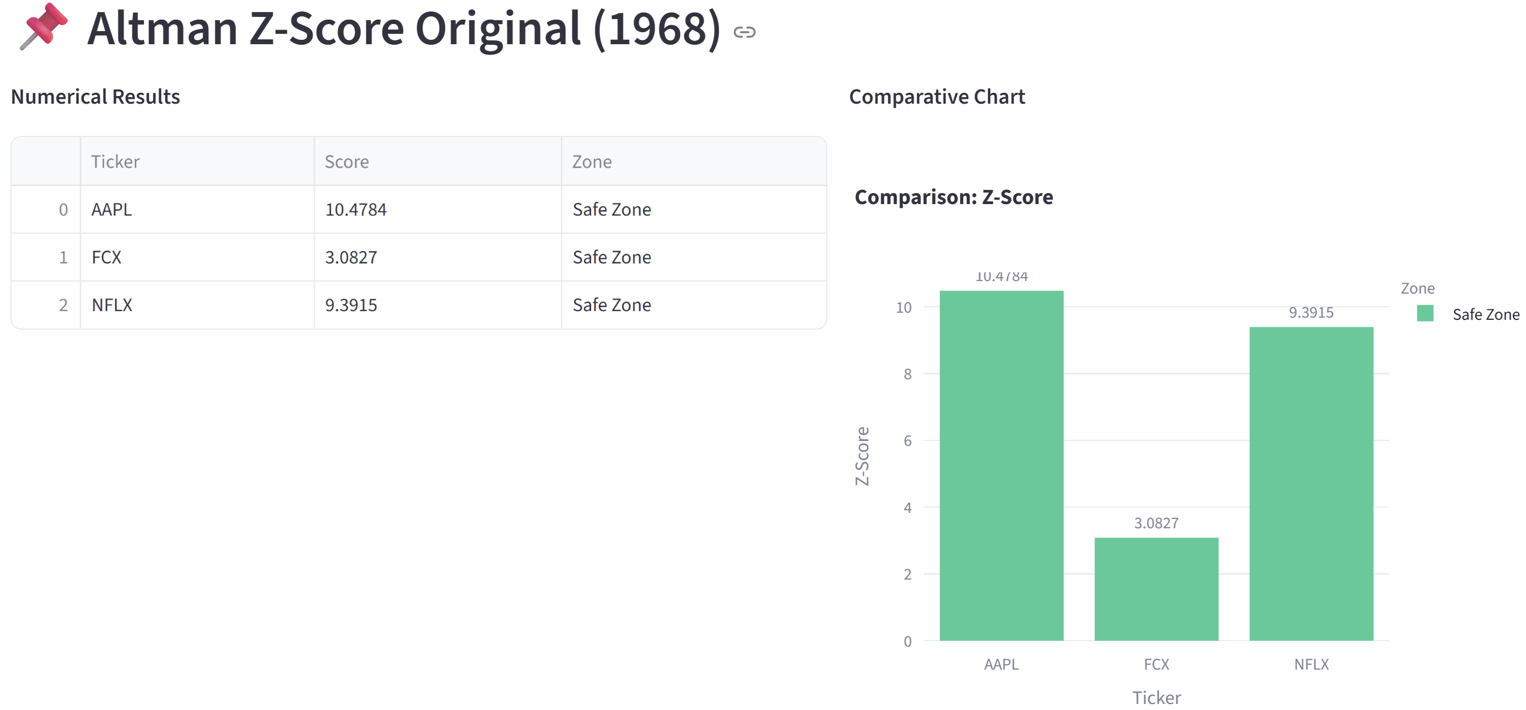
With the results obtained by the original model, the three companies achieved outstanding scores that placed them in the "safe zone," making them eligible for credit (Apple with a Z-Score of 10.4784, Netflix with 9.3915, and FCX with 3.0827).
However, the situation changes when the Altman Z-Score model is applied, which was initially designed for emerging markets or non-manufacturing companies. Since this model eliminates sector bias, companies like Apple and FCX drop in the rankings with scores of 2.3078 and 2.4570, respectively, which makes sense considering that this model does not fit their characteristics as companies. Interestingly, Netflix remains in the safe zone with a score of 5.3158.
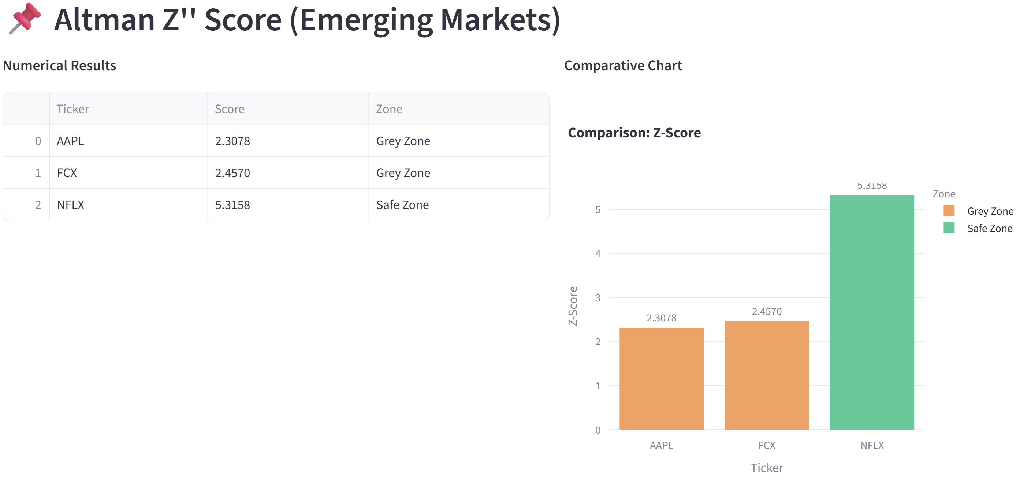
Now, from a market perspective, Merton's model has yielded quite positive results for all three companies.
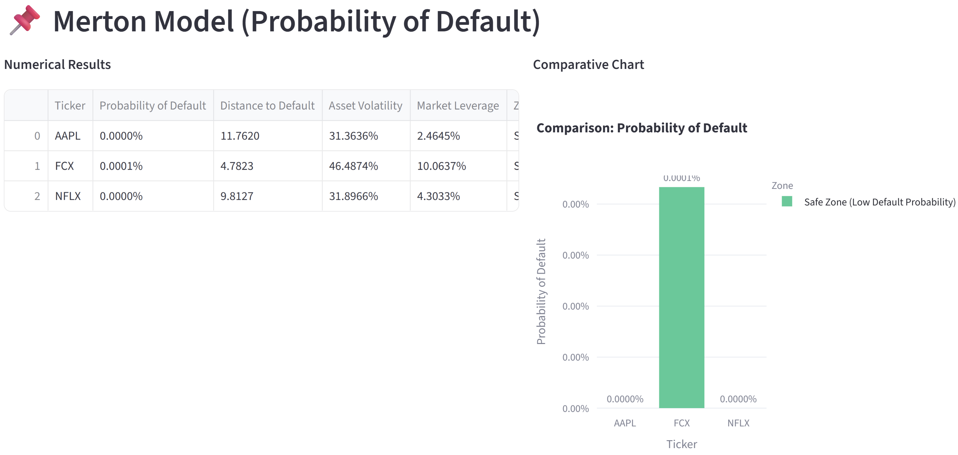
This also makes sense considering the size of the companies and that the analysis period was set at a single year. More specifically, Apple has a massive DD of 11.76, while FCX shows the lowest DD (4.78) due to its higher asset volatility (46.48%) and highest market leverage (10.06%) within the group. However, despite its higher volatility, its insolvency risk is still considered "safe" in the short term.
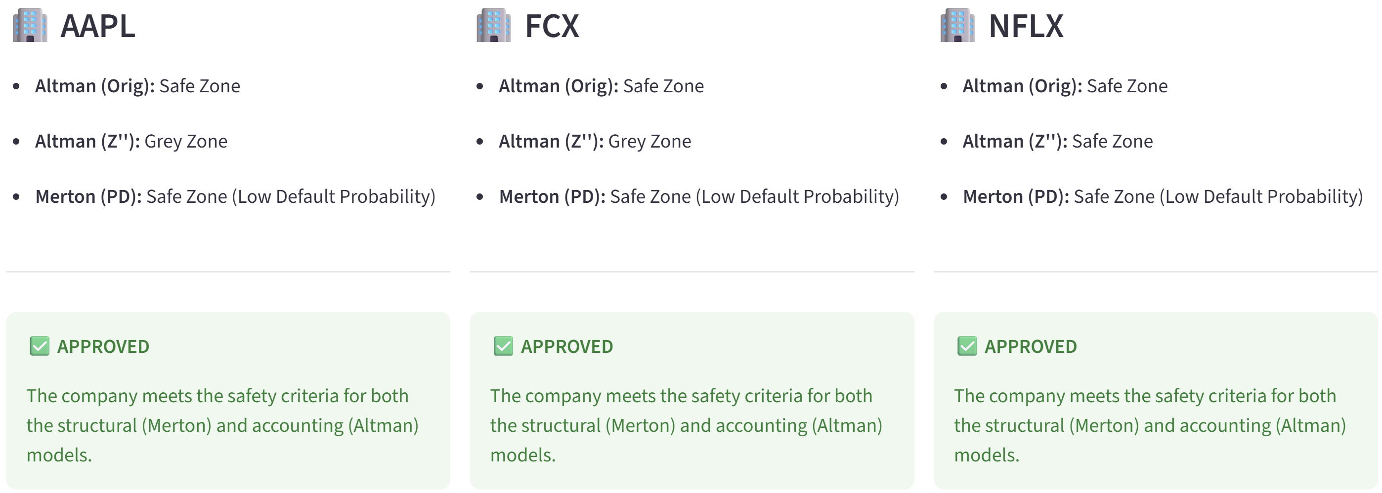
With all this in mind, the loan was approved for all three companies, following the rule that at least one Altman model and one Merton model must classify the company as being in a "safe zone."

Conclusion:
The pronounced difference between the results of the three models for a company like Apple demonstrates why it is important to have a variety of models available and why it is necessary to apply the correct model according to the nature of the company. On the one hand, it is clear how the original Altman model gives significant weight to asset turnover, which, when applied to a technology company like Apple, generates high scores, creating a false impression of absolute security or stability. On the other hand, when compared with other models that work differently and eliminate some biases, it is clear that the scores still vary, which suggests that risk assessment cannot depend entirely on a single formula that works universally. What is truly important is not to concentrate on a single model and to conduct a truly informed analysis that considers as much observable data as possible from a company, as well as different perspectives, before issuing a judgment.

References:
- Pantoja-Aguilar, Martín P., Pizano-Ramírez, Guadalupe de Montserrat, Lerma-Torres, Berenice, & Zavala-Vargas, Miguel Ángel. (2021). Testing Altman’s Z’’-Score to assess the level of accuracy of the model in Mexican companies. Nova scientia, 13(27), 00019. Epub 21 de febrero de 2022.https://doi.org/10.21640/ns.v13i27.2881
- Benos, A., & Papanastasopoulos, G. (2007). Extending the Merton model: A hybrid approach to assessing credit quality. Mathematical and Computer Modelling, 46(1-2), 47–68. https://www.sciencedirect.com/science/article/pii/S089571770700026X
- Kenton, W. (2024, 30 de mayo). Altman Z-Score: What it is, formula, how to interpret results. Investopedia. https://www.investopedia.com/terms/a/altman.asp
- Slay, R. (2023). Altman Z-Score Presentation [Diapositivas de PowerPoint]. ITESO - Universidad Jesuita de Guadalajara.
- Slay, R. (2023). Merton model KMV: An introductory overview of the Merton model [Diapositivas de PowerPoint]. ITESO - Universidad Jesuita de Guadalajara.

